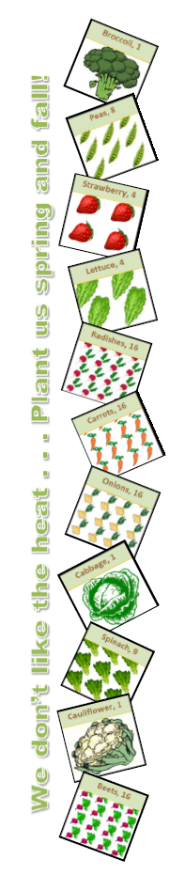
JANUARY
Pea Planting. Soak seed overnight and sow direct in your vegetable garden. Start them under row cover fabric, but once up and growing they laugh at the cold. Also, plant cool weather leafies including leaf lettuce, spinach, greens and chard, especially under row covers, a short row or two every couple of weeks.
Cole Crops. Toward the end of the month, you can plant flats of cole crops (like broccoli) under lights indoors for spring transplanting in March.
FEBRUARY
Start Seeds Indoorsfor Spring Cool Season Transplants.
Transplant Preparation. In order to transplant in mid-March, start brassicas like broccoli, cabbage, and bok choi, plus lettuces.
MARCH
Planting Preparation. It's time to plant cool spring vegetables, including broccoli, lettuce, spinach, greens, cabbage, chard and root crops,
Seed Starting. It's time to start tomatoes, peppers and eggplants indoors,
Direct Seeding. Direct seed mustard, lettuce, spinach, radishes, turnips, beets, carrots (don't delay), onion sets, chard, mâche, mesclun, and Asian vegetables (try gai lan, 'Chinese flowering broccoli', it's great and easy.). Anything that prefers cool weather and grows fairly fast.
APRIL
Seed Starting. During the first week or two of April, you can still start warm weather flowers and vegetables indoors, like zinnias, asters, marigolds, sage, tomatoes and peppers.
Temperature Tip. After mid-month, once danger of frost is past, nighttime temperatures are above 10 degrees C (50 degrees F), and soil temperatures are above 15 degrees C (60 degrees F), it's time for tomato and annual flower transplants, and for direct seeding beans, cantaloupe, corn, cucumbers, pumpkin, squash and watermelon. (I wait until May to sow okra, and to transplant peppers, eggplant and sweet potatoes).
MAY
Sow and Transplant. You can sow or transplant beans, black-eyed peas, Crowder peas, cantaloupe, squash, melons, pumpkins, cucumbers, sweet corn, okra, hot weather lettuce mixes, tropical greens, basil, tomatoes, eggplants, peppers, and sweet potatoes.
Crop Care. Harvest your cool season crops regularly, keep them watered and weeded. When the snow peas show signs of heat fatigue, you can dig them right into the bed to enrich the soil, or contribute to the compost.
JUNE
Healthy Herbs. Leafy herbs like basil will start to flower. When you see the first signs of flowering, harvest the top. Pesto time!
Transplant Cole Crops. Toward the end of the June, start Brussels sprouts, collards and other brassicas in flats for transplanting into the garden in early August.
Happy Harvest. Keep harvesting your tomatoes, cukes, squash,peppers and other fruiting crops, or they will lose interest in producing and put their energy into seed.
JULY
Harvest Time. Harvest herbs and veggies on a regular basis. Don't let your zucchini reach cetacean proportions—pick it before you need a harpoon to deal with Moby Zuke. Also, harvest your Irish potatoes when the tops begin to brown and die back.
Start Fall Plantings. Start fall vegetables, including broccoli, cabbage, collards, kale, cauliflower and Brussels sprouts.
Late maturing crops - Approximate maturity 90 days. Plant by mid July for fall harvest, later for spring harvest.

ROOTCROPS
- Beets
- Carrots
- Parsnips
- Rutabaga
- Globe Onions

LEAFCROPS
- Brussells Sprouts
- Cabbages
- Cauliflower
- Fava Bean

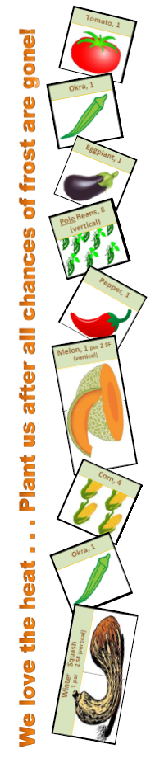
AUGUST
Planting Time. Plant varieties of bush beans ('Contender', 'Provider'), cucumbers ('Poinsett', 'Marketmore 76') and squash (yellow crookneck and straightneck, pattypan, 'Zephyr' from Johnny's seed) that mature rapidly.
Mid-season crops - Approximate maturity 60 days. Plant by mid August. Use any of the dates from above as well as the Best Dates below.

ROOTCROPS
- Early Carrots
- Leeks
- Turnips
- Kohlrabi

LEAFCROPS
- Early Cabbages
- Winter Cauliflower
- Collards
- Swiss Chard

SEPTEMBER
Early maturing crops - Approximate maturity 30 days. Plant by mid September. Use the dates from the previous page as well as the Best Dates below. The latest dates are for warmer climates, later frosts, or protected plantings.

ROOTCROPS
- Chives
- Bunching Onions
- Radishes

LEAFCROPS
- Broccoli
- Leaf Lettuces
- Mustard & Spinach

OCTOBER/NOVEMBER
Prepare Veggie Beds. If you have time, with all the planting, clean up and composting going on, try to get some vegetable beds prepared for spring planting. Till or double dig each bed and add organic matter. Wait on high nitrogen fertilizer, such as dried manure or commercial organic blends like Espoma 'Plant-tone' (5-3-3) until planting time in the spring.
Clean Up the Garden. Remove dead vegetable plants from the garden to prevent insects and diseases from overwintering.

Remember to keep diseased plants and weed seeds strictly out of your home compost.
Keep Up Your Garden Care. Be sure to keep on top of weeding, thinning, harvesting and watering with your cool season vegetables.

ROTATION OF VEGETABLE VARIETIES
This is a very critical part of any garden scheme. Do not plant the same fall or winter vegetable crops in the same location as they were planted the previous year or the summer season. It is important to note that if the same crop is planted in the same location, not only will the soil be weakened through continual loss of the same nutrients but the plants will also attract the same insects and diseases to that part of the garden.
Source: http://www.rodalesorganiclife.com/garden/monthly-garden-calendar-southeast-united-states

Totally different website for monthly garden planning:
https://www.almanac.com/gardening/planting-dates/AR/Saratoga

